**History and Evolution of Generative AI**

**Objectives**

After completing this reading, you will be able to:

* Describe the key developments in the field of generative AI in chronological order
* Explain the current scenario of generative AI

**Introduction**

Generative artificial intelligence (AI) is a field that focuses on developing algorithms to create new content, such as text, images, music, and code. Generative AI models are trained on substantial datasets of existing content and learn to generate new content similar to the data they were trained on.

**History**

The origin of generative AI origins can be traced back to the initial stages of artificial intelligence exploration. In the 1950s, researchers began to explore the use of computers to generate new data, such as text, images, and music. However, the computational power and data resources needed for these systems to flourish were not yet available.

One of the earliest instances of generative AI dates back to 1964 with the creation of the **ELIZA chatbot.** Operating on a rule-based system, ELIZA simulated conversations with users by generating responses based on received text. While not genuinely intelligent, ELIZA showcased the potential of generative AI for human-like communication.

During the 1980s and 1990s, hardware and software capabilities advanced considerably and facilitated the development of advanced generative AI models, including **neural networks**. Neural networks are inspired by the human brain and can learn intricate patterns in data. However, these early neural networks were computationally expensive to train and could only generate small amounts of content.

In the early 2000s, a significant breakthrough occurred in generative AI research with the advent of **deep learning**. Utilizing neural networks with multiple layers, deep learning models could be trained on extensive datasets to discern complex patterns, enabling the generation of new data that closely resembled human-created content. This breakthrough led to the development of innovative generative AI models, including generative adversarial networks (GANs) and variational autoencoders (VAEs).

GANs and VAEs excel at producing high-quality content that is often indistinguishable from content crafted by humans.

**GANs** operate by training two neural networks in opposition: a generator that creates new content and a discriminator that tries to differentiate between real and synthetic content. Eventually, the generator learns to craft content realistic enough to deceive the discriminator.

**VAEs** work by learning a latent space of the data they are trained on. The latent space is a representation of the data that captures the most essential features of the data. VAEs can generate new content by sampling from the latent space and decoding the latent code into the original data space.

In recent years, there has been a rapid explosion in the development of new generative AI models. These models can now generate a wide variety of content, including text, images, music, and code. Generative AI is also used in various applications, such as art, design, and healthcare.

One such instance is the development of **diffusion models** in 2015. Diffusion models work by gradually adding noise to a clean image until it is completely unrecognizable. They can then be reversed to gradually remove the noise and generate a new image. Diffusion models have been used to create high-quality images and text.

The next significant development is that of **large language models (LLMs) like GPT-3**and **Gemini** in 2020 and 2023, respectively. LLMs are trained on massive datasets of text and code, which allows them to generate realistic text, translate languages, write different kinds of creative content, and answer your questions in an informative way. 2023 was also when **watsonx**, a superior generative AI platform based on the cloud, was introduced by IBM. Watsonx can support multiple LLMs.

Here is a brief **timeline** of some of these milestones in the fascinating journey of generative AI:

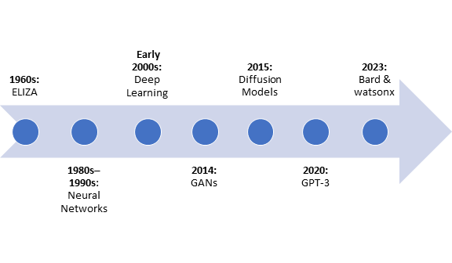

**1960s: ELIZA**

ELIZA, an early chatbot, showcased early attempts at simulating conversation.

**1980s–1990s: Neural network development**

Researchers started developing more sophisticated generative AI models, including neural networks, capitalizing on advances in hardware and software.

**Early 2000s: Deep learning**

Deep learning, a breakthrough in AI, gained prominence. Neural networks with multiple layers were employed for training on massive datasets.

**2014: Generative adversarial networks (GANs)**

Introduced by Ian Goodfellow and his colleagues, GANs presented a revolutionary two-player neural network framework.

**2015: Diffusion models**

The development of diffusion models brought a novel approach to image generation by gradually adding noise to a clean image.

**2020: GPT-3**

OpenAI released GPT-3, a state-of-the-art language model, demonstrating impressive natural language understanding and generation capabilities.

**2023: Gemini and watsonx**

Another large language model, Google’s Gemini, and IBM's generative AI system, watsonx are introduced, further advancing the capabilities of generative AI.

These milestones represent an overview of the generative AI journey, capturing vital developments in natural language processing, image generation, and the underlying architectures that have shaped the field over the years.

**Current scenario**

Generative AI is still a relatively young field, but it has already significantly impacted the world. Generative AI is being used to create new forms of art and entertainment, develop new medical treatments, and improve businesses' efficiency. As generative AI advances, its potential societal implications are expected to broaden significantly.

Presently, these are some of the specific instances highlighting the current applications of generative AI:

* **Art and entertainment**: Generative AI is being used to create new art forms, such as AI-generated paintings, music, and literature. Generative AI is also being used to develop new video games and other interactive experiences.
* **Medicine**: Generative AI is being used to develop new medical treatments, such as personalized cancer therapies and AI-powered drug discovery. Generative AI is also being used to develop new medical imaging tools and improve diagnosis and treatment accuracy.
* **Business**: Generative AI is being used to improve the efficiency of businesses by automating tasks such as customer service, marketing, and sales. Generative AI is also being used to develop new products and services.

Generative AI holds significant transformative potential across various facets of our lives. Using generative AI responsibly and ethically is essential, but it is also important to be excited about its possibilities.

**Summary**

In this reading, you learned about the history of generative AI. You noted the key developments in chronological order. You learned about the contribution of each key development to the field of generative AI. Finally, you learned about the current scenario of generative AI.